Rethinking Telecentre Sustainability: How To Implement A Social Enterprise Approach - Lessons From India And Africa

Mayanja Meddie
Senior Program Officer for telecentre.org at IDRC
<mmayanja@idrc.ca>

Abstract
Telecentres today are the key to telecentres of tomorrow. If they succeed in achieving their objectives, there is no doubt that development partners, social investors and governments will have a fresh look at the potential of telecentres to development. In June 2005 the government of Ghana launched the first of its two hundred thirty telecentres to be established across the country. In Rwanda, US $ 1 million has been set aside for a countrywide telecentres program. All these are some of the bold initiatives that will be boosted by exquisite telecentre planning today. Financial and social sustainability of telecentres remains one of the key challenges of the digital inclusion programming more than a decade after. The author uses field-based experiences from India and Africa to review varied telecentre sustainability approaches. While analysing the strengths and weaknesses of each of the approaches he makes an argument for a new approach – one that will ensure high social capital, sustainability and financial sustainability for telecentres.

Introduction
Telecentres today are the key to telecentres of tomorrow. If they succeed in achieving their objectives, there is no doubt that development partners, social investors and governments will have a fresh look at the potential of telecentres to development. In June 2005 the government of Ghana launched the first of the two hundred thirty telecentres it will be establishing across the country. In Rwanda, US $ 1 million has been set aside for a countrywide telecentres program. All these are some of the bold initiatives that will be boosted by exquisite telecentre planning today.
Financial and social sustainability of telecentres remains one of the key challenges of the digital inclusion programming more than a decade after. For instance in Mali, if nothing is done to address social and financial sustainability by the end of the year when social investors are scheduled to withdraw, the majority of telecentres and community radios will struggle to survive.
However this is not to suggest that nothing has been done about these key challenges as yet. Communities continue to innovate and experiment with several approaches to sustainably delivering ICT tools. Prominent approaches include Community Information Centres (CIC), Community Multi-media Centres (CMC), Information kiosks, cyber cafes, School-Based Telecentres (SBT) and more. This article reviews some of the current approaches to telecentre sustainability from Africa and Asia. It focuses mainly on the principal elements necessary to create a successful approach – borrowing from a score of approaches.
Telecentres present a huge opportunity for extending ICT access to rural communities in a flexible manner. They are meeting places where people access appropriate technologies, services, exchange ideas and connect to social networks. They have a huge potential to influence a development vision of a rural community by rallying civil society and government towards addressing pressing community needs. The Songhai Centre in Benin and the M.S Swaminathan Foundation in India have risen to that desirable influential status already. Several telecentres have embarked on this path as well.
Whether telecentres remain an influential component in the community development agenda in the long run however, depends on how they respond to the urgent need to build social and financial sustainability capacities.

The social development approach
This approach believes in helping individuals and communities to address social needs. At the centre of the approach is the urge to help the disadvantaged and excluded less resourced majority of a community. This approach is strong on building awareness and growing the culture of ICT use. In that sense, it might be very useful in creating the necessary conditions for enterprise approach to work effectively according to Richard Fuchs, (former) Director ICT4D @ IDRC.
The social development paradigm has been largely about building social capital as an engine for creativity, networks and sustainable growth. Where by social capital is the total sum of person-to-person or institutional interactions and mutual support. Therefore the resilience of a community is measured by the amount of social capital at its disposal.
The civil society and telecentres have been instrumental in growing social capital in communities by providing free of charge services for selected activities. Sections of the community that would otherwise be excluded from benefits of ICT have been brought into the mainstream through targeted activities. The main stay of telecentres largely remains government subsidies and development partners. This is the case for M.S Swaminathan Foundation in India.
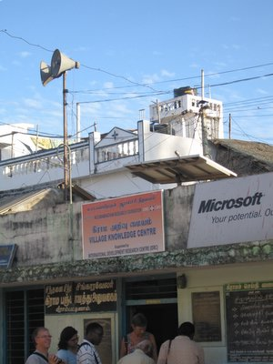
M.S Swaminathan has a number of telecentres (Village Knowledge Centres) in south India rooted in the community development - knowledge creation and sharing program. In Pondecherry members of the community access indigenous knowledge, agricultural information, Internet and training services at no direct cost. The foundation undertakes fundraising activities to underwrite telecentre services. For instance, the government of Pondecherry pays for access to some services interpreted to have a high community development value. Telecentres are specifically designed to meet special needs of fishing, crop farming and cattle keeping communities. Users can either walk into one of the centres of choice or receive information – like location of best fish catches for fishing community) via loud speakers placed in strategic meeting places in the community.
The approach generates considerably high social capital since it is community driven but it is weak on financial sustainability. Dr. A R Thiagarajan describes M.S Swaminathan approach as a social service. He fears that asking people to pay for services at the information centres is not possible and will only exclude the people the foundation aims to serve. Indeed the model demonstrates a high return on social capital building. It fits well for the communities that are relatively poor with low literacy rates and a supportive public sector.
The big question is whether the M.S Swaminathan foundation can be replicated in India or any other community in Africa with equal success especially without matching donor support. Those who have followed telecentres in Africa might realise a number of similarities with Nakaseke MCT (Uganda), Sengerema MCT (Tanzania) and a score of others in South Africa.

The Enterprise or Information Kiosk approach
The Enterprise approach is about developing services for sale. While such services may bring a community development value, the choice of a particular service is made against its selling value more than its community development potential. This approach is not ideal for pre-market communities, which explains why most times it locates on high streets and urban areas.
India presents a number of telecentres operated under the information kiosk approach. An enterprise-based model where decisions about the site, management, technology, and services are based on the business case the community offers. One such example is the Drishtee franchise model.
Drishtee information Kiosk in Delhi
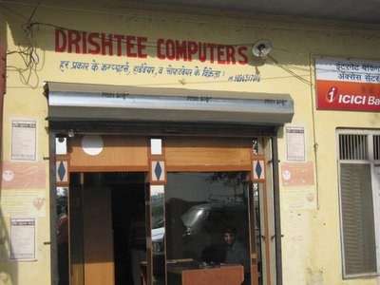
Drishtee is a limited company and operates a franchise of 1,000 kiosks across India (Feb 2006). Any individual may apply for a loan with a 3-year repayment period to set up a kiosk in a community of choice. Loan beneficiaries receive training in business planning and management (soft skills, PC operations and trouble shooting and service development), a computer, UPS, backup battery and software as part of the whole package. When it started three years ago, Drishtee had a cocktail of 58 services offered but this has currently been reduced to 16 only, reportedly because “…that is what the community can pay for” (Mishra S. – CEO Drishtee dot com). Drishtee acts as the brokers for services; it identifies demand and matches it with services suppliers and information kiosks. For that, kiosks pay Drishtee an average of 500 Rupees per month for support services on top of the loan serving.
The four Drishtee information kiosks visited in Delhi area are on the road to a financial sustainability. In the overall, owners (entrepreneurs) were interested in the success of respective businesses. In that respect, it can be fairly concluded that the Drishtee model is a source of employment and services to the communities. Kiosk services included computer training, English language training, sale of Insurance services and medical referrals with the Heart Research Centre all at a fee. It’s a mix of online and offline services. The centres would have done more if they had better connectivity and stable power supply. The Drishtee approach is strong on financial sustainability in the short term. Entrepreneurs were optimistic that they could pay back the loan and stay in business.
This approach is akin to cybercafés in Latin America and Africa too. The most popular of which are the BusyInternet in Ghana and Lotus cybercafé in Uganda. The main characteristic is that they target people in the middle and upper part of the social pyramid. This often will not work in pre-market communities.
Cybercafe in Chennai – India
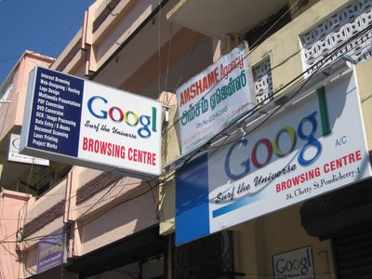
Key success factors include availability of infrastructure, a community that knows which services it needs accompanied with capacity to pay. The approach would not work in rural areas because it has very low social capital development potential as such weak in terms of social sustainability. If it ever finds users with capacity to pay, they will be very few to sustain the model. That largely explains why both in Africa and India, the approach is used in urban and semi urban areas.

Walking The Middle Line: The Social Enterprise Approach
The community development and enterprise models are both fantastic approaches to delivering ICT. Individually, each one of them is weak in key aspects desired for financially and socially sustainable telecentres. This can be viewed in another perspective too; the enterprise approach will bring dismal returns without a strategy to grow and empower the user base (market). Social investment is critically required to continuously facilitate innovative access and use of technologies and services upon which the enterprise approach thrives. Likewise, the community development approach will struggle if it cannot meet costs of inputs and services for which fees are required.
Reflecting about a similar situation Lester Thurow in the Economic Community and Social Investment in the Community of the Future (1998) observed: “Capitalist infrastructure can only be built behind or slightly ahead of the market…the internet could not have been privately financed, usage wasn’t there, would take twenty years to develop…but, in the end, a social investment in infrastructure provided the means for developing an exciting set of new private industries.”
Clearly the solution lies in blending the two. In practice the two approaches should work together to create the necessary awareness, opportunities for creativity, allow uptake of technologies and services and ensure diffusion of innovation.
Social capital chat by Pete Cranston
The social enterprise model takes the best out of the two models. It pre-supposes that there will be people in the community with no or less capacity to pay for essential services along side those who are happy to pay for felt needs. While tapping into social support systems, it acknowledges the responsibility for financial independence and sustainability as a virtue for telecentres. The recipe is also as much in walking the middle line. Telecentres have to make decisions about the appropriate mix on a case-by-case basis.
Datamation Foundation in India is a good example of a social enterprise model. It provides a number of information services to the community free of charge. It however runs parallel training programs at a fee in addition to targeted fundraising. Datamation Foundation is more to the community development model with a fair mix of enterprise approach elements. The Songhai Center in Benin is yet another institution operating on a social enterprise model. The centre runs a cocktail of community development services - free and at a cost. It is an ideal place to illustrate this approach.
Centre Songhai Telecentre in Benin
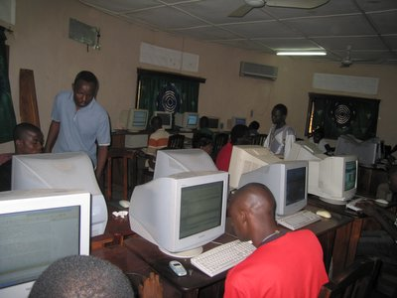
Social enterprise model is indeed about finding the “perfect balance” between community development and enterprise approach.
Tricks That Work: Implementing the Social Enterprise Approach In Telecentres
Implementing the social enterprise approach requires commitment and discipline. It calls for a gradual shift in practice in the way a telecentre is managed be it a community or an enterprise approach (Mark Surman, Managing Director telecentre.org @ IDRC).
From a community approach…
A telecentre would start by identifying key services that users can and are willing to pay for and go ahead to develop a price for each with an advertisement plan. The telecentre would start at:
- a cost recovery fee structure, gradually move to a…
- little profit fee structure (to subsidize essential services) and ultimately…
- provide services that combine a social value with economic benefit to individuals and community.
The first and second levels would have services that are not essential to individual or community survival. Examples include; printing digital photos, downloading music from the Internet, playing computer games or making business cards. Charging for such services would subsidize essential community services. The third and more advanced level would involve for example e-commerce services, or e-medical consultations which, while they appear costly indeed help the individuals to save time and resources thereby retaining scarce resources in the community for other pressing needs.
From an Enterprise Approach…
An information kiosk operating on demand and with a profit motivation would need to make a commitment to re-orient itself as well. The best way to start would be to identify key community development needs and services with high community development value. Such services would benefit from lower charges at the first level. Depending on space and resource availability, an information kiosk may choose to print health, agriculture and market price information from CD ROMs or Internet at half price as a way of generating traffic.
At a more developed level, the information kiosk may provide market information for farm produce; helpline services on agricultural related problems; participate in distributing information concerning epidemics and pandemic control and management of diseases like diarrhoea; cholera or HIV/AIDS. The benefit to the community might come in two ways; availability of a service (like market information for farm produce) that addresses an essential need of the community and a lower cost that makes social inclusion for access to the service possible.
…The role of networking
In the information society what you give away comes back to you several folds
– Johan Enberg, former ITU Director
Networking is fundamental to achieving a balanced and successful social enterprise model. That means engaging stakeholders on both sides of the divide to enhance learning and understanding of how each of the models work. Fortunately, partners from each school of thought in India and Africa are keen to find a telecentre management approach that promotes access to ICT services on a sustainable basis. That is a key ingredient for success.

