**Visions, Participation and Engagement in New Community Information Infrastructures**

Authors

Affiliation

**Abstract.** Through the past seven years, our research group has engaged in a participatory action research collaboration with a variety of community partners to explore understandings, possibilities, and commitments for a new community networking infrastructure in State College, Pennsylvania. This paper describes a case study of multifaceted information technology infrastructures, and of collaborating with the plethora of actors and institutions that are stakeholders in such infrastructures. Information technology projects increasingly depend upon the commitment and energies of a great diversity of stakeholders. Understanding better how such broad projects move forward is critical to society.

**Keywords:** Participatory Action Research,Information Infrastructures, Community Networks, Location-based Services, Feed Aggregation.

**Introduction**

Community networks are ensembles of online tools and information for users who live in proximity to one another. Early community networks employed relatively simple text-oriented messaging such as bulletin boards and email lists. They posted local opinions and classified ads, but also focused on educational equity, minority cultural preservation, needs of the homeless, public health, domestic violence, and political dissent (Schuler, 1996). They tended to be created and maintained by hobbyists, who often creatively adapted equipment and approaches eschewed by more mainstream computer installations. These efforts made information technology into a civic *activity*, as contrasted to a professional service or consumer product.

In the latter 1990s, community networks migrated into the web, and experienced a brief and intense period of growth. They exploited the enhanced accessibility of the Internet, and the expressive power and technical simplicity of early HTML. There were ironies in this; for example, posting community information became easier, but engaging in community discussion became less easy. But the Internet of Web 1.0 rapidly attracted commercial interests on a global scale. In just a few years time, most websites of local merchants and nonprofits pointed to their corporate/headquarters portals. Many specialized sites developed. Government information migrated to government sites. Tourism information migrated to tourism sites. By the early 2000s, the concept of community network had fragmented into a chaos of redundant and commercial or semi-commercial portals, often carelessly maintained.

We believe that the overarching objectives of community networking are to enhance end-user participation in the design of community technology, and in the production and exchange of community information. However, the context for community networking has changed: User expectations about Internet services are far more demanding. People expect up-to-date information, and value-added interactions. A new generation of community networks incorporating wireless access, location-based services, syndication and feeds, recommendation and sharing, and other Web 2.0 functionalities is at hand. Yet, creating community network infrastructures that can support richer interactions and dynamic information requires tools that are far more sophisticated than HTML editors. End-user stewards of community information and technology often lack the required tools and skills.

Since 2003 our research group has participated in an extended participatory action research project (Whyte, 1989) with a variety of community partners in the town of State College, Pennsylvania. State College is a town in the United States consisting of about 42,000 people who live in the rural center of Pennsylvania; another 40,000 people live in surrounding townships. The town of State College is immediately adjacent to the main campus of the Pennsylvania State University. In this project, we have worked closely with about twenty community non-profit groups, including the local food bank, sustainable development groups, a group that builds housing for the economically disadvantaged, a child welfare group, a group that coordinates local emergency response, the local public access television, the local heritage society, local arts groups, the downtown improvement group, the regional library, as well as the local schools and municipal government.

As a participatory action research project, our goal has been to learn while doing; to directly cooperate with community members and institutions to facilitate community interests and activities with respect to information and technology; and in so doing to learn more about possible models and techniques for community-oriented and community-based technology. We work closely with community partners to understand what our neighbors do, what they value, and what they want to do. We jointly analyze problems and opportunities, and plan and carry out initiatives.

In this paper, we present a narrative overview of this project, organized as three activity threads that describe how we facilitated (1) a community learning process to help community members think about technology possibilities with respect to their own goals and interests, and begin to develop skills required to interact with these; (2) a series of empirical requirements studies and prototyping efforts exploring more concretely how community members could appropriate new technologies, such as location-based wireless services and feed aggregation; and (3) a strategic planning process to help community leaders envision new infrastructure possibilities, recognize their stakes in these possibilities, and become committed stakeholders in the planning. Each of these activity threads has allowed us to enlist key community allies.

The three activity threads enable, support, and enrich one another. Taken together, they suggest an emerging “model” for constructing multifaceted social and institutional infrastructures, integrating community technology and community activity, and enhancing civic participation and engagement.

**Community Learning**

One thread of our project is community learning. In 2003, many community groups had developed web pages to enhance their visibility to the larger community, as well as to organize specific functions such as making announcements and receiving donations. With US National Science Foundation support, we organized a 4-year project to leverage these efforts into a community-wide informal learning process about information technology. We investigated how community groups were organizing themselves to articulate goals, to learn skills, and to institutionalize effective practices with respect to information technology, particularly the novel technologies emerging through the web. We had a specific interest in investigating whether and how groups might want to incorporate collaborative interactions and services into their web sites; this derived in part from our research interests in web-based collaboration (e.g., Ganoe et al., 2003). To make the project manageable and focused, we structured it into three cycles of 2-year partnerships. In each cycle, we recruited four local nonprofits to work with us; they reflected on how they were currently using the Web, what was going well or poorly, and identified key information technology tasks they would like to accomplish. We also asked them to think about the organizational roles and processes they would need to sustain a learning process that could help to address such challenges in the future. In return, we helped them reflect and plan, and we helped them address specific technology needs.

The outcomes from our community learning investigation varied through the years. Early on, we documented fascinating examples of how even technologically sophisticated groups were often disempowered with respect to their own information technology. For example, a sustainable community planning and development group centered on the local water ecosystem (Spring Creek) had hired a local web designer. This contractor created a website design that the group considered a cliché (emphasizing images of frogs, grasses, and a pond), and that did not convey their mission (Farooq et al. 2007). They were unhappy, and refused to even allow the site to go public because the pages used bamboo in its background – “an invasive species […] stuff we pull out”. They also felt powerless; the designer hosted their datasets and other information on his server, and was not responsive to their concerns. In another example, we discovered that one of our partners was securing its database by isolating from the Internet the machine that hosted the database. This was effective, but also made the database more cumbersome to access and maintain.

Some of the challenges we observed among the local nonprofits were management issues. Thus, many groups had no technology plan whatsoever. Their reasoning was that it did not make sense to plan for technology when they had so few resources to invest in it. Most of the groups relied on volunteers as their webmasters and system administrators, but volunteers tend to come and go in nonprofit groups. One group we worked with was still using a database that no one currently in the group understood how to maintain. Also, some of the challenges we observed were identity issues: One group leader told us flatly that no one joins a local nonprofit group to manipulate software. (See Merkel et al., 2007).

The learning episodes had both short- and long-term implications. In the short-term, members of our partner groups became more comfortable, literate, and skilled with respect to web technologies like HTML. For example, we assisted the sustainable development group by introducing low-tech approaches like sketching and scenarios to envision the website they wanted (one that emphasized a wider range of environmental impact issues, such as storm water runoff). They were able to control these media to better specify what they wanted from a web design, and eventually to build their own more satisfying version of a website (Fig. 1). In the longer term, the groups experienced greater autonomy and control of their own web information technology, and began to develop practices that could sustain transformation. This group subsequently decided to build technology-related knowledge management practices within the group itself, reducing its future dependence on outside technical experts. The group began to maintain a record of website management activities, so that future volunteers could more easily and reliably learn to maintain the website.

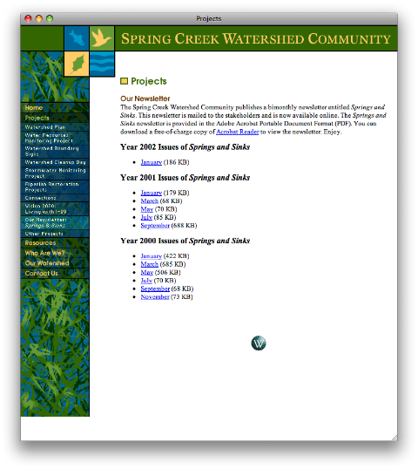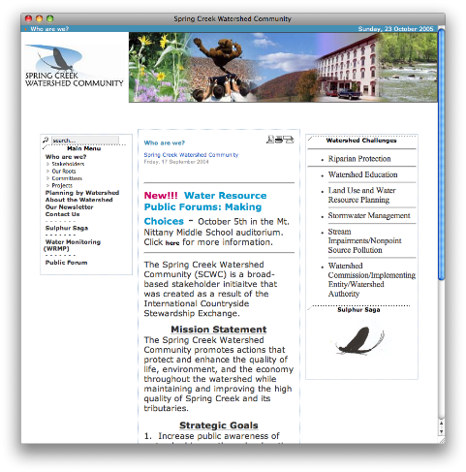

Fig. 1: Before/after images of Spring Creek website

We also helped to organize a series of community information technology workshops (CITWs), both to recruit more partners and to disseminate our findings and recommendations to the larger community. At these events, we and other community members provided tutorials and demonstrations of new technologies and approaches. There have been five such workshops: October 2003, October 2004, August 2005, August 2006, and April 2010, with a sixth scheduled for October 2011. The first four CITWs progressed from fairly small events that were focused on recruiting partner organizations and sharing results, to broad discussions of information technology needs and resources of community nonprofit organizations, including half-day and full-day tutorials on new technologies (see Carroll, Bach, Rosson, Merkel, Farooq & Xiao, 2008 for details on CITWs 1-4).

The first CITW focused on helping potential partners to problematize information technology and to share their ideas and goals. We reviewed projects we had previously completed in the Blacksburg Electronic Village (Carroll, 2012), and demonstrated new web technologies. The content of the succeeding CITWs highlighted the information technology achievements and plans of the State College community. In some cases, these were particular designs, such as the revised web site for the sustainable development group. In other cases, these were organizational practices to better ensure an IT learning process that would enable a group to address design and technology management challenges in the future.

From this work, we identified a series of organizational learning patterns (Carroll & Farooq, 2007; Kase et al., 2010). For example, as mentioned above, the sustainable development group developed management practices to create better documentation, to enhance organizational learning. This is especially critical for community nonprofits, which necessarily depend on volunteer members for critical information technology tasks. However, volunteers are not always IT professionals, and there is high turnover among volunteers. We observed a pattern we called Scaffolded Documentation in which key knowledge assets are identified and minimally documented. This pattern applies recursively: If documentation is not correct or complete, it can be enhanced. If knowledge assets not yet documented come to light, a starting set of documentation can be generated. This pattern is unlike the comprehensive information management practices one might find in the commercial or government world, but it is robust and efficient in the local nonprofit context.

More recent CITWs have had an expanded agenda, looking more broadly at community-level planning processes for IT infrastructures along with enabling tools and skills. At the 2006 CITW we discussed results from a community survey (carried out in spring 2006) that showed that while the vast majority of community groups do have a strategic plan, most do not engage in strategic planning for technology; most do not have a budget line item for technology; and most have no paid technology support staff. Twice as many respondents were dissatisfied as satisfied with the technology training possible in their organization. And by far, information management and website design were identified as the biggest organizational challenges. A major theme in the 2006 CITW was skills and concepts for content management systems, Joomla in particular. Several tutorial sessions were provided as well as a discussion of whether and how the community might organize to adopt and support content management systems.

The most recent CITW focused on how Web 2.0 tools might support common organizational tasks, as well as enabling groups to more reach out to the community in a more effective fashion. For example, Google’s online tools for documents and calendars were demonstrated as lightweight ways to accomplish collaborations and communication within an organization. Tools and services for creation of RSS & calendar feeds were also demonstrated as a way to publicize the issues and events of these organizations, and to streamline this through services like Facebook and Twitter. While these Web 2.0 services are in personal use by many web-savvy digital natives, the idea of interlinking these services to better achieve community information and outreach goals is not something these community organizations have been considering. For them, maintaining an IT infrastructure along with an online presence is often experienced as one more demand on already limited resources. With live presentations of the lightweight configurations needed to create targeted and effective web mashups, we introduced Web 2.0 tools that not only are of value to individual organizations but also serve as building blocks for improved information sharing within the community.

Looking back, a key to the CITW process has been the involvement of anchor community institutions, for example the regional public library, the local public access media (created in the US initially as part of regulatory structure for cable television, and similar to open channels in European countries), and a set of downtown businesses (via the Downtown State College Improvement District, DSCID). An important factor in building and sustaining this long-lived and broad community learning process is a stable cohort of individual actors: From 2003, we have been collaborating with many of the same community leaders.

Ideally, local government should be a central stakeholder in the community’s technology learning and infrastructure planning. The Borough of State College was directly involved in the planning process for the 2006 CITW, and part of the event was held in Borough Hall. However, the primary actors in local government can change abruptly and organizational memory can be lost. Local elections in November 2006 brought in new supervisors who had not participated in previous CITW processes, were largely unaware of what was involved, and were skeptical about the role the Borough should play in planning for local IT infrastructures given the availability of commercial service providers. Since 2006, the Borough government has played only a minor role in the CITW process.

In summary, we learned that community groups face diverse and significant challenges with respect to information technology. They are poorly resourced for information technology because they are poorly resourced in general. For the same reason, they lack planning and management practices for technology, and knowledge management practices in general. They often lack specific technical skills and knowledge because they rely on the unpredictability of volunteering. However, we found that with modest support, the groups we partnered with were eager and creative in adapting their practices. Through the CITW process we observed that nonprofit groups were very receptive to opening up a community discussion about technology skills and practices, unmet challenges, and new possibilities.

**Technology Explorations**

The second thread in our project is a series of empirical requirements studies and prototyping efforts that have explored how community members might react to and appropriate new technologies (e.g., aggregation of local community information, and location-based, mobile, and wireless services). In the summer of 2006, we participated in a series of webinars produced by the James S. and John L. Knight Foundation and Intel Corporation examining wireless infrastructures as an approach to providing pervasive Internet access to urban communities, with a particular focus on the Knight-supported Wireless Philadelphia project. Working with both Knight and Intel, we planned a complementary community wireless project in State College, to explore the new civic affordances of wireless community networks, such as volunteering-on-the-fly for community service, place-based discussions of community issues, and place-based access to community heritage information (Carroll & Ganoe 2008; Carroll & Rosson, 2008).

We carried out a series of interviews, surveys, and focus group discussions with members of community groups (Burge et al., 2009). We observed a high level of interest in our scenarios, but also apprehension about the perceived difficulty of managing mobile interactions. We concluded that we needed to provide people with direct experiences of emerging new technologies.

The resulting technology explorations have included participatory design work with community leaders as well as public field trials of design prototypes within the community. To help community members visualize and obtain a concrete sense of how technology could support community activities, we developed prototypes that presented information about community events with a focus on mobile, location-sensitive presentation and interaction. In one case, we partnered with the Central Pennsylvania Festival of the Arts, a group which produces both a five-day summer festival (of the same name) and a one-day New Year’s Eve celebration (“First Night”) annually, so that we could understand how significant community events are planned and organized. We chose to work around these major festival events because they evoke a critical mass of community participation. Working from an open-source wiki engine (JSPWiki), we developed a prototype that offered an interactive calendar of events, where visitors could see what activities were coming up in the next few hours, search events by time and location, and visit the individual pages of events to read additional information, view pictures, or share comments with others. This prototype was accessible on the web or on any device with an Internet connection; the presentation was simplified for fast loading and minimal clutter for small mobile device displays.

Once we had developed an initial prototype, we conducted field trials of the wiki-based tool during two popular community events: the 2008 Central Pennsylvania Festival of the Arts in the summer and the First Night State College 2009 activities on New Year’s Eve. Community members were made aware of the prototype, and we recruited a small number to take handheld devices with themselves during these events so that they could try out the prototype and provide feedback.

While this early prototype presented benefits to the community members who participate in these community events, it was not without its limitations. The database of information about the events (time, location, descriptions) was manually compiled and entered (by us) and thus was not easily editable by the public. Wiki pages could address an event or events, but users had to use the special wiki syntax we had developed to specify the event’s time, categories, location, etc. for them to appear on the summary calendar pages, to be searchable or to have map-related capabilities. Furthermore, because the prototype was aimed at specific community events it did not yet reflect a model for long-term use or community integration that could increase awareness and appropriation by community members.

The next iteration of the prototype addressed some of these drawbacks. We partnered with StateCollege.com, a local commercial portal for news, events, business information, and so forth for the State College area. StateCollege.com already hosted a calendar that citizens could use to publicize local community events. While StateCollege.com was a commercial endeavor, its interest in promoting the informational needs of our community partners made some type of collaborative partnership attractive. Moving from our wiki platform, we integrated our mobile event prototype design with their desktop-oriented community calendar. While functionally similar to the wiki-based application, the mobile event tools we developed in partnership with StateCollege.com calendar enabled users to submit events that are merged into the database. Once in the database, these events appear on the calendar, and are integrated within the StateCollege.com site, thus inheriting mobile and desktop views, user commenting, and search. In short, we merged our prototype’s features with theirs and built on this to not only better achieve our aim but also to improve their community calendar. This prototype was field tested during the 2009 Central Pennsylvania Festival of the Arts.

One contrast between our first wiki-based system and the new prototype was that calendar events were now editable only by the person who originally submitted the event (and site administrators). One positive was that other community members did submit new events related to the Arts Festival, but a downwnside was that some entries had errors that could no longer be fixed by our team or the Central PA Festival of the Arts staff, because they were not entered by us. While we could email StateCollege.com with fixes (for example, locational directions to an on-campus event in a building instead pointed to an open field), this process took time and some issues did not get corrected before the event.

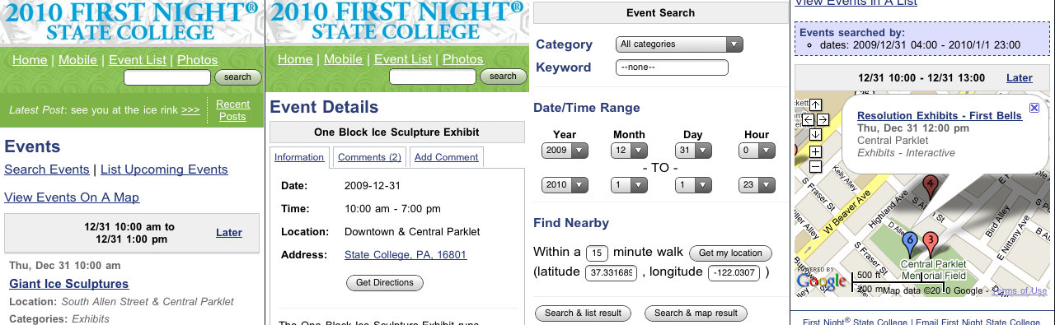

Fig. 2: First Night 2010 mobile design – event list and awareness notification (left); event details, directions and comments (center left); search page that includes keyword search capabilities and location awareness features (center right); and map view of search results (right).

Overall, we felt the prototypes were evolving in the right direction to support community activities, but we still needed to explore more options for leveraging technology. We conducted one final iteration with the revised prototype as part of the First Night State College 2010 website itself. First Night 2010 was another community festival similar to the Central PA Festival of the Arts. This time we did not partner with StateCollege.com; this allowed us to work directly with the First Night State College database and integrate features for enhanced viewer awareness.

In retrospect, one conflict between the vision we developed with our non-profit community partners and our partnership with StateCollege.com was that the latter understandably saw ownership of the data on their site as part of their business model. While clearly *for* the community, a moderated calendar is still not really *by* and *of* the community. We also felt that there was room for improvement in developing a prototype into something that more exactly met the needs and opportunities of a community wireless network. Part of the basic rationale for wireless access is that the network use can occur in many different locations, and these many different settings may cause different activities to be possible or useful. Taking location-sensitive development and community ownership of information as two points of design re-focusing, we began creating an updated prototype.

We were still interested in the opportunities for community network use of mobile technologies, but we shifted to community usage scenarios that make more direct use of Web 2.0 services. Keeping in mind our aim to evoke and support a wide variety of community interests and goals, we focused on the potential impact of real-time information feeds, from both Internet-based and local community organizations or individuals. We also generalized our exploration of location-specific services, such that the location-specificity would apply to multiple forms of community information, not just calendar events. A primary concern in this was to enable varied individuals and groups within a community to develop, share and maintain information as part of a community system. We support the aggregation process through Web information standards for Web feeds (e.g., RSS, ATOM), which allow us to pass up-to-date information from a source to a viewer. We have recently begun to explore the usefulness of these aggregated feeds of community-related information as a means of gathering and presenting diverse information from across a community in one central location.

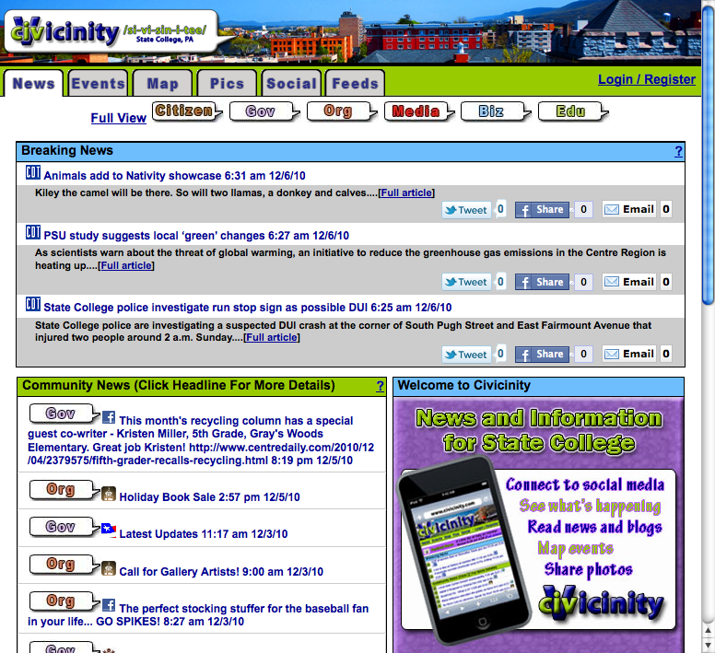 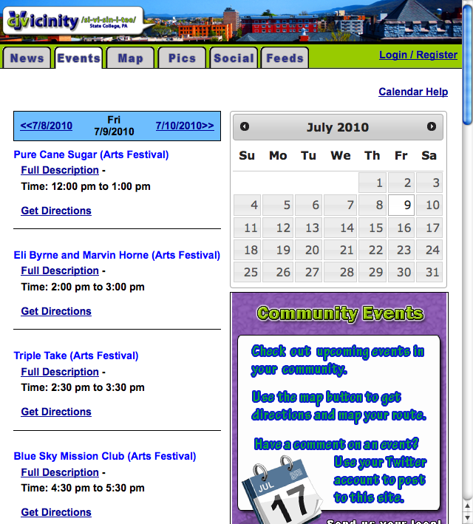

Fig. 3:. CiVicinity news feed page (left) and Arts Festival calendar (right).

The current prototype – CiVicinity – leverages this simple concept of feed aggregation (Fig. 3). Feeds push content from a web-based sources to readers, so they provide regulars updates as the source updates its content; feed technologies have been widely adopted by all sorts of outlets, including professional media, amateur bloggers, and social networking systems like Facebook. This relatively simple concept gave us considerable community participation power, as our system could now provide access to all sorts of relevant community information.

Using the RSS or Atom standards, any web-accessible site can syndicate its content automatically, making it available to clients without having to publish multiple versions or multiple times. CiVicinity uses these standards to gather news and stories published by a wide variety of community organizations, groups, and individuals, aggregating them in one place. We also included calendar updates, so as to expand the coverage of the shared information and to support our earlier interest in location-specific event information. Calendar information sharing is supported by the increasingly popular iCalendar format that handles updates in a manner similar to feeds. Thus we used RSS, Atom and iCal, to develop a site that aggregates a wide variety of information from across the community in one location. The information presented is composed of stories, news, events, and posts made by the community, eliminating the need for our team to manually add information, or for community members to submit individual updates for re-publication. CiVicinity is now a one-stop shop for community news, community events, as well as convenient access to the sites and organizations that generate this information.

Currently we are expanding our technology explorations with CiVicinity. For example we have prototyped new features that allow viewers to customize their interactions with available community information. Entries are labeled and categorized by source type, allowing for easy discrimination among professional media such as local newspapers, government outlets such as the Centre County Government, and sources affiliated with the university such as Penn State Live. By making use of these categories, readers may choose to explore feeds of a similar type, for instance accessing less recent stories that are not shown in the default view. CiVicinity users who authenticate (log in) can also select specific feeds to see or not see. Additionally, readers can share community information entries with other members of their online social networks or to their email contacts. We are currently conducting a series of laboratory experiments to study the effect of these design choices on users’ reactions to the site, and in particular their perceptions of the value of community news and the efficacy of the community in meeting its goals.

**Infrastructure Planning**

After the third CITW workshop, a group of community leaders from the regional library, the public access television, and a child welfare group initiated a planning process directed at creating a more continuous community learning mechanism and a more comprehensive information infrastructure for nonprofits, and for the community in general. These efforts were important in helping to organize and realize the next CITW. They also helped to focus community discussion about information infrastructures. Thus, after the third CITW, there was a concerted effort to engage the municipal government of State College to coordinate development of an infrastructure. The James S. and John L. Knight Foundation, a U.S.-based organization which supports innovation in journalism, media and community engagement, offered to support this initiative under its Knight Communities program (www.knightfoundation.org). Unfortunately, after a local election, State College turned strongly away from playing this coordinating role. The fourth CITW initiated a discussion of developing and supporting a standard content management system (CMS) configuration for local nonprofits.

After our fifth CITW workshop in 2010, a group of community partners including the regional public library, local public access media, and our youth services bureau met to discuss the currency of local information sources and the concept of a more comprehensive community calendar. This led to the idea of developing software that would support a wide variety of feed types in order to maximize adoption from our local non-profit groups. For our lab, this meant that we developed software that would aggregate “news” from both RSS and Atom feeds pushed out from various community websites (i.e., as already described for the CiVicinity prototype). In addition, we developed a calendar aggregator designed to collect iCal feeds, which are supported by such projects as Google Calendar, Apple iCal, MS Outlook, and IBM Lotus Notes.

We pursued the information aggregation approach for multiple reasons. First, we recognized that the solution to a robust community calendar was not to simply gather and present local community information via a portal, but instead work toward a more dynamic vision of continuous collection, where the information we present is created and broadcast from a wide variety of community sources. The benefit of this is first that non-profit groups would not have to visit and update yet another ‘community calendar;’ instead they simply push their information updates using the technologies on our site. Second, we saw that the same principles could be used to aggregate local content from non-profit organizations, and we felt that non-profit messages would be more likely to be read by members of the community if they were located in spaces that were information rich. Part of the challenge for smaller non-profits, in other words, is that they often have just a few items of “news” and “events” to promote each year. In our discussions with our community partners we decided that a centralized calendar that housed all of these items would be a richer source of information than the sparse, disaggregated information that was currently available for citizens at multiple non-profit websites.

As a result, our research team spent the next several months developing the web-based CiVicinity prototype to meet these objectives. Our prototype contained 43 local feeds from a wide variety of information sources, including local professional media, non-profit groups such as the local food bank and Red Cross, local schools, independent bloggers and local government. One early finding that came from this iterative process of developing a prototype and discussing these designs with our community partners was the realization that the information design needed some sort of filtering mechanisms. We soon realized that there were significant differences in the number of times that each of these organizations updated their own content. The food bank, for example, might release an announcement for an event weeks in advance, while the local newspaper updated twice a day. When all of these feeds were aggregated together, it quickly became apparent that the more regularly updated feeds would push other important events off the page. As a result, we designed the presentation of the aggregated information such that they were distributed into different sections of our page that we called breaking news, community news, and Penn State University news. The goal was to not “bury” the less frequent updates within the steady stream of the more regular updates.

Our monthly meetings focused on both software design issues and the larger goal of developing a plan for implementing the software on a community wireless network. At this point, our group faced the challenge of building a network without local borough council support. On October 6, 2008 our local borough council met to discuss prior plans to implement a wireless network in the downtown area. At that time, the council received a resolution to discontinue planning and development of a municipal wireless network, based on information they had received that the private sector was expanding wireless access, albeit primarily private access, to parts of the borough. As a result, council members voted unanimously to suspend the project. In our additional correspondence with local borough IT employees, we learned that the borough council decided not to move forward with these plans in part because a recent survey conducted by the borough showed that most downtown residents in downtown already have access to high speed internet. At the monthly meetings with our non-profit partners, we discussed this decision and determined that part of our initial focus must thus be to demonstrate the *value* of community wireless access, i.e. beyond simply ensuring Internet access to residents.

We agreed that the project should focus on three immediate concerns. First, we envisioned that a community wireless network downtown should provide new opportunities for non-profit organizations, businesses and local government to interact with both community members and visitors. Second, we also recognized that such a network would be used by a variety of wireless technologies accessing our network with different tasks in mind. With this in mind, we began to explore designs that would support both a mobile and desktop version of our site. We also began to explore the potential of geo-location services. The interest in geo-location grew out of the recognition that location information about events could enhance civic, social and economic interests and support new kinds of interactions on mobile computing platforms. For instance, individuals who view our information might be more ready to volunteer for local activities near them. They could also obtain directions to activities, or track news events occurring near places they frequent. We also discussed the potential for location-based advertising that could be of benefit to the local businesses participating as stakeholders in this planning process. It is important to observe that our community partners are not commercially motivated, but nonetheless have seen the potential for a collective venture between local business and non-profits, as a means for developing a sustainable community wireless network.

A final goal expressed at these meetings focused more directly on what might be a long-term sustainable model for a community wireless network. Our members expressed two areas of concern. First, there were technical questions relevant to the hosting and maintenance of such a network. Most of our community partners have IT expertise and are already spread quite thin in their respective positions. Many work full time to support their specific organizations, while also volunteering additional services for other groups in the community. While they were eager to lend support to the initial development of a network, they knew that plans should take into consideration long-term support. In addition to this concern, our members also recognized that a project of this scale would need a business model that supports both implementation sustainability of the network. Routers, ISP providers, and page updates all incur some costs, and our stakeholders questioned how we would sustain the infrastructure.

Given these concerns, the members of the planning group recommended that we discuss our plans and the CiVicinity prototype with members of the business community, who might see the commercial potential of a wireless network and who would perhaps be amenable to supporting larger non-profit goals. Business members in our downtown area are members of a local non-profit known as the Downtown State College Improvement District (DSCID). The DSCID promotes the interests of local businesses downtown and also works towards advertising and maintaining a positive image for Downtown State College to attract visitors and promote community. As a result, we approached the Executive Director of DSCID to discuss interest in working with our other non-profit partners on the project.

The DSCID Director saw in our project the potential to advance his own organizational mission. Since those initial meetings we have collaborated with him to craft a resolution of support for our CiVicinity plan from the DSCID Board of Directors, and will continue with the Board’s support to obtain a resolution of support from the State College Borough Council. It is important to note that his goals for a community network were very different from our non-profit partners, but that both groups of stakeholders saw the potential of a cooperative agreement. For the DSCID, a wireless network had the potential to meet two overarching needs. First, it could increase the time that individuals spent downtown once they were there, as they used our network in various cafes and restaurants to locate services, to identify sales, and perhaps discover reasons to soon return. Second, the director discussed a need to make it easier for individuals to visit the downtown area, given the concerns such as finding parking. We discussed at this point the idea of developing parking availability on our public network and of incorporating public transportation schedules. We also began to discuss commercial activities on the network such as location-based advertising that could leverage the location aware features of mobile devices and new browser standards that would allow the businesses to target customers using our network at a nearby location. In addition, we considered the potential uses of a wireless network for providing multi-day updates from local restaurants and other establishments that would be interested in promoting sales and daily specials.

After these initial meetings with our community partners, we created a scenario-based survey presenting the envisioned potential social, economic, and civic uses of a wireless, location-aware community information system. Scenarios have proven valuable in engaging the local community in a participatory design process by allowing us to present concrete stories of use through which we can generate interest and more nuanced feedback from the community. We presented three distinct scenarios, each designed to describe social, economic and civic activities that could be done on wireless devices, along with a 194-item survey to assess the interests and motivations of potential users, to 404 participants from the local community. Controlling for a range of factors such as length of residence, current civic and online activities, and technical competence, both social and civic uses were seen as more appealing than economic uses. And overall, those respondents who were not already engaged in civic and social uses of the internet were somewhat more likely to be interested in our civic and social scenarios.

From a practical standpoint, such a survey allows us to provide data to our various stakeholders concerning what designs we expect to optimize use and user satisfaction. For example, less interest in potential economic uses may present an issue for our business-oriented partners but also such insights can be applied to the ongoing design. Of course, scenarios do not predict the long-term affect of our design, such as how users will perceive the system over time and how they will use in the long term. But they do give us insight into the interests and motivations of those who will live with the community network as we continue the participatory design process.

Since our initial meetings, some tensions have surfaced between the commercial and nonprofit partners, as they negotiate the goals and plans of the wireless community network. In part, the tensions arose from different visions. The DSCID was tasked with the goal of serving the business interests in the downtown; the non-profit stakeholders represented the interests beyond the downtown area. While both could quickly agree that coordination of local commerce and nonprofit information was mutually beneficial, differences emerged over implementation details. To address these, we organized another series of meetings, the result of which was to reinforce the two side’s mutual interest in moving forward with planning and seeking initial resources. At present, we plan to test the mobile version of CiVicinity using the wireless connectivity that already exists in the downtown area. Once we assess the potential with both groups of stakeholders we will revisit their goals and discuss plans to move forward in a way that meets both sets of needs.

**Summary and Concluding Remarks**

The Internet paradigm has dramatically expanded the possibilities for a wide range of actors and roles in shaping information systems. The most recent developments in this paradigm, popularly known as Web 2.0 tools and technologies, have enabled an era of enhanced participation and end-user design.

Community networking is an important, yet distinctly challenged arena of organizational participation in Web 2.0 development. In the United States, for example, community nonprofit groups bear substantial responsibilities for providing social services, such as food and affordable housing for disadvantaged people, and civic services, such as libraries, public media, and arts and heritage support for all citizens. The core mission of these groups is to engage and empower people where they live. They are all about citizen participation. Yet these groups are poorly resourced in general, and especially under-resourced with respect to information technology. They must rely on hardware donations, on open source or discounted software, and on volunteer expertise. Participation and end-user design are essential.

In this paper we described our long-term participatory action research collaboration with a variety of local nonprofit groups in State College, Pennsylvania, and more recently with representatives of local businesses. We have presented this work as three interwoven story threads: (1) a community learning process in which the goals and interests of community groups were connected to technology possibilities and the skills and concepts required to achieve these possibilities, (2) a series of requirements and prototyping studies exploring and demonstrating how technologies, such as location-based wireless services and feed aggregation could be useful, and (3) a community planning process to envision new infrastructure possibilities, recognize their stakes in these possibilities, and become committed stakeholders in the planning.

Each of these threads of activity helped us to recruit key community allies. In many cases, the three threads were symbiotic: Our initial efforts to help local nonprofits develop sustainable information technology learning practices made the CITWs seem an obvious and modestly incremental step. But that step brought hundreds of additional community members into the project. Our technology development and prototyping have helped our partners appreciate that possibilities are quite achievable and can be practical, but also that they have key roles to play in those outcomes. Our prototypes have encouraged partners to set more ambitious technology goals. These activities, in turn, helped our community leaders recognize that a broader planning process was feasible and necessary, and that an alliance among non-profits and businesses is a cornerstone in such a process.

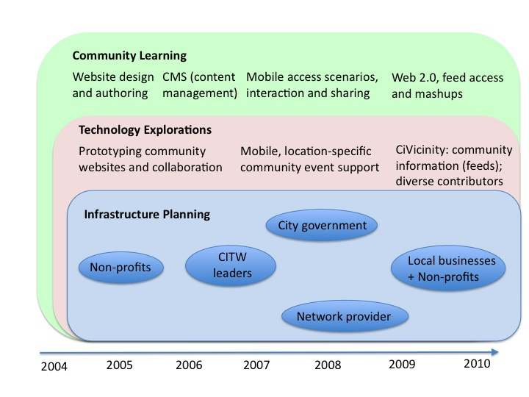

Fig. 4: Three threads in our project.

The centrality of community learning to community networking cannot be overstated. But it is neither feasible nor sufficient to enroll community volunteers in commercial tutorials. In our experience, community nonprofits do not, and in many case cannot budget for such training, and worse, the volunteers are not engaged by the prospect of such training. However, we found that technology learning was more attractive when community members describe their own experiences and innovations to their neighbors, as in the CITW series. This creates a virtuous cycle between technology exploration and community learning: Information technology provides a rich canvass for modest innovations, and sharing results engenders a culture of participation in technology learning and innovation.

We observed that learning about information technology was more clearly motivated in the context of planning community technology infrastructures. Part of this is that learning in a real context makes learning matter more. But part of it is that conceptualizing community networks as information infrastructures emphasizes how community activity and information draws its value from network externalities. It is not an accident that aggregating community information and making wireless access available throughout the community were the central themes in our technology explorations. These enhancements do not merely add to value to a community network, they multiply value.

The specific lessons of this project are of course provisional. They are primarily directions for deeper investigation. Our experience encourages a conception of effective community action as coordinating engagement and initiative along multiple threads of activity. In our case these have consisted of community learning, technology explorations, and infrastructure planning. We suggest that achieving a culture of participation requires such synergies.

In the section on community learning we highlighted the benefits of working with key “anchor institutions” in our community network planning. We found that working with the local library, public access media, the borough council and a child welfare group in our community provided the basis for a large and growing network of communications among a wide variety of community partners. Each of these organizations had their own tacit knowledge of the needs of a significant set of stakeholders in the community, whether human service organizations, the community’s civic groups or public media. These anchor institutions were essential in representing those diverse needs as part of the shared learning process. In addition, our interactions with this anchoring group of stakeholders led to additional contacts over the years with other community partners who have also helped (and are continuing to help) inform the directions for our research.

In the section on technology explorations we reflected on challenges that can arise when partnering with commercial partners. StateCollege.com is a locally owned news and information portal that has been working for several years to create a web presence as a hyperlocal news source. To some extent their goals were aligned with our action research agenda, in that we both aimed to create a multi-purpose community information portal. However, our partnership dissolved in part because their commerical orientation led to constraints on research access to databases and server data. Admittedly, commercial organizations have good reason to be leery of providing access to external parties and we certainly understood such concerns. Nonetheless, the access limitations means corresponding limitations on the changes we could make to our experimental prototype as well as the usage data we could glean to guide prototype evolution and refinement. As a side effect, the non-profit organizations that were contributing data or feeds to the site were unable to learn much about how their information was being used by members of the community. This commercial partnership, in other words, had trade-offs that worked against a sustainable working relationship. While StateCollege.com had the time and financial resources to invest in a community network, the proprietary nature of the organization was too limiting for a collaborative partnership.

Finally, the discussion on Infrastructure and Planning emphasized how important it is to demonstrate the added value of community networks to our community partners. When we began to explore the idea of a wireless community network that would use our CiVicinity portal as a landing page, our local government initially understood this to be simply an issue of access. Our challenge was to move them beyond thinking of networks in terms of *who* had access and instead consider *how* the network could be leveraged to improve aspects of community life. Currently we are working with our partners to develop a small-scale wireless network in a busy section of downtown. The wireless network will use the CiVicinity portal as its landing page. We have taken this approach to provide data to our community partners that can motivate them to reach out to and engage residents in the longer term. We have learned that our community partners, particularly the borough council and our local businesses, need to see how the network can benefit the community organization, citizens, and local businesses before that are willing to put large investments into infrastructure.

While the research presented here shares specific experiences and offers a set of initial lessons learned, it is important to underscore that cultures of participation are by no means entailed by the Internet or by Web 2.0. At most such a culture is afforded by these more interactive online technologies. Moreover, Web-based information systems like Facebook and the ensemble of Google applications show in a compelling way that global consolidation of services, and the relegation of many users to the more traditional role of information and service consumer is still a likely trajectory Technology will only entrain cultures of participation when it is integrated into multifaceted social and institutional infrastructures, predicated upon the interdependence of technology and human activity, and aimed primarily at enhancing participation and engagement among the greatest possible variety of human actors.

**Acknowledgements**

This work was sponsored by the United States National Science Foundation (under award numbers 0342547 and 0511198), by the James S. and John L. Knight Foundation, by Intel Corporation, and by the Edward M. Frymoyer endowment. A short paper version was presented at the 3rd International Symposium on End-User Development (Carroll, Horning, Hoffman, Ganoe, Robinson & Rosson, 2011).

**References**

Burge, J.D., Campbell, L.M. & Carroll, J.M. (2009). Community wireless networks: Field exploration of non-profit participation. *Symposium of Human-Computer Interaction at ASIST 2009,* Conference of the American Society for Information Science and Technology (Columbus, Ohio, 26 October).

Carroll, J.M. (2012). *The neighborhood in the Internet: Participatory design research projects in community informatics.* London: Routledge.

Carroll, J.M., Bach, P., Rosson, M.B., Merkel, C.B., Farooq, U., & Xiao, L. (2008). Community IT Workshops as a Strategy for Community Learning. *First Monday, 13, 4* (http://www.uic.edu/htbin/cgiwrap/bin/ojs/index.php/fm/article/view/2052/1955)

Carroll, J.M. & Farooq, U. (2007). Patterns as a paradigm for theory in community-based learning. *International* *Journal of Computer-Supported Collaborative Learning. 2(1),* 41-59.

Carroll, J.M. and Ganoe, C.H. (2008) Supporting Community With Location-Sensitive Mobile Applications. In M. Foth (Ed.), *Handbook of Research on Urban Informatics: The Practice and Promise of the Real-Time City.* Hershey, PA: Information Science Reference, IGI Global.

Carroll, J.M., Horning, M., Hoffman, B., Ganoe, C.H., Robinson, H. & Rosson, M.B. (2011). Community Network 2.0. *Proceedings of 3rd International Symposium on End-User Development: IS-EUD.* (Torre Canne, Brindisi, Italy, June 7-10). Berlin: Springer Lecture Notes in Computer Science, pages 270-275.

Carroll, J.M. & Rosson, M.B. (2008). Theorizing mobility in community networks. *International Journal of Human-Computer Studies:* Special Issue on Mobility*, 66*, 944-962.

Ganoe, C.H., Robinson, H.R., Horning, M.A., Xie, X. & Carroll, J.M. (2010). Mobile awareness and participation in community oriented activities. *COM.Geo 2010: Proceedings of the First International Conference and Exhibition on Computing for Geospatial Research and Application.* (Washington, D.C., June 21-23). ACM, New York, NY, pages 1-8.

Ganoe, C.H., Somervell, J.P., Neale, D.C., Isenhour, P.L., Carroll, J.M., Rosson, M.B. & McCrickard, D.S. (2003). Classroom BRIDGE: using collaborative public and desktop timelines to support activity awareness. *ACM UIST 2003: Conference On User Interface Software and Tools.* New York: ACM, pages 21-30.

Farooq, U., Ganoe, C. H., Xiao, L., Merkel, C, Rosson, M.B. & Carroll, J. M. (2007). Supporting community-based learning: Case study of a geographical community organization designing their web site, *Behaviour & Information Technology: Special Issue on Computer-Support for Learning Communities*, 26, 1, 5-21.

Kase, S., Zhang, Y., Carroll, J.M. & Rosson, M.B. (2010). Synthesizing IT case studies of nonprofits using a multiple-level patterns-based framework. *IEEE Transactions on Professional Communication, 53(3),* 216-232.

Merkel, C., Farooq, U., Xiao, L., Ganoe, C., Rosson, M. B., and Carroll, J. M. (2007). Managing technology use and learning in nonprofit community organizations: methodological challenges and opportunities. In *Proceedings of CHIMIT 2007: Symposium on Computer Human Interaction For the Management of Information Technology* (Cambridge, MA, March 30 - 31, 2007). ACM, New York, NY, Article 8.

Schuler, D. (1996). *New community networks: Wired for change.* New York: Addison-Wesley.

Whyte, W.F. (1989). Advancing scientific knowledge through participatory action research. *Sociological Forum, 4,* 3. 367-385.