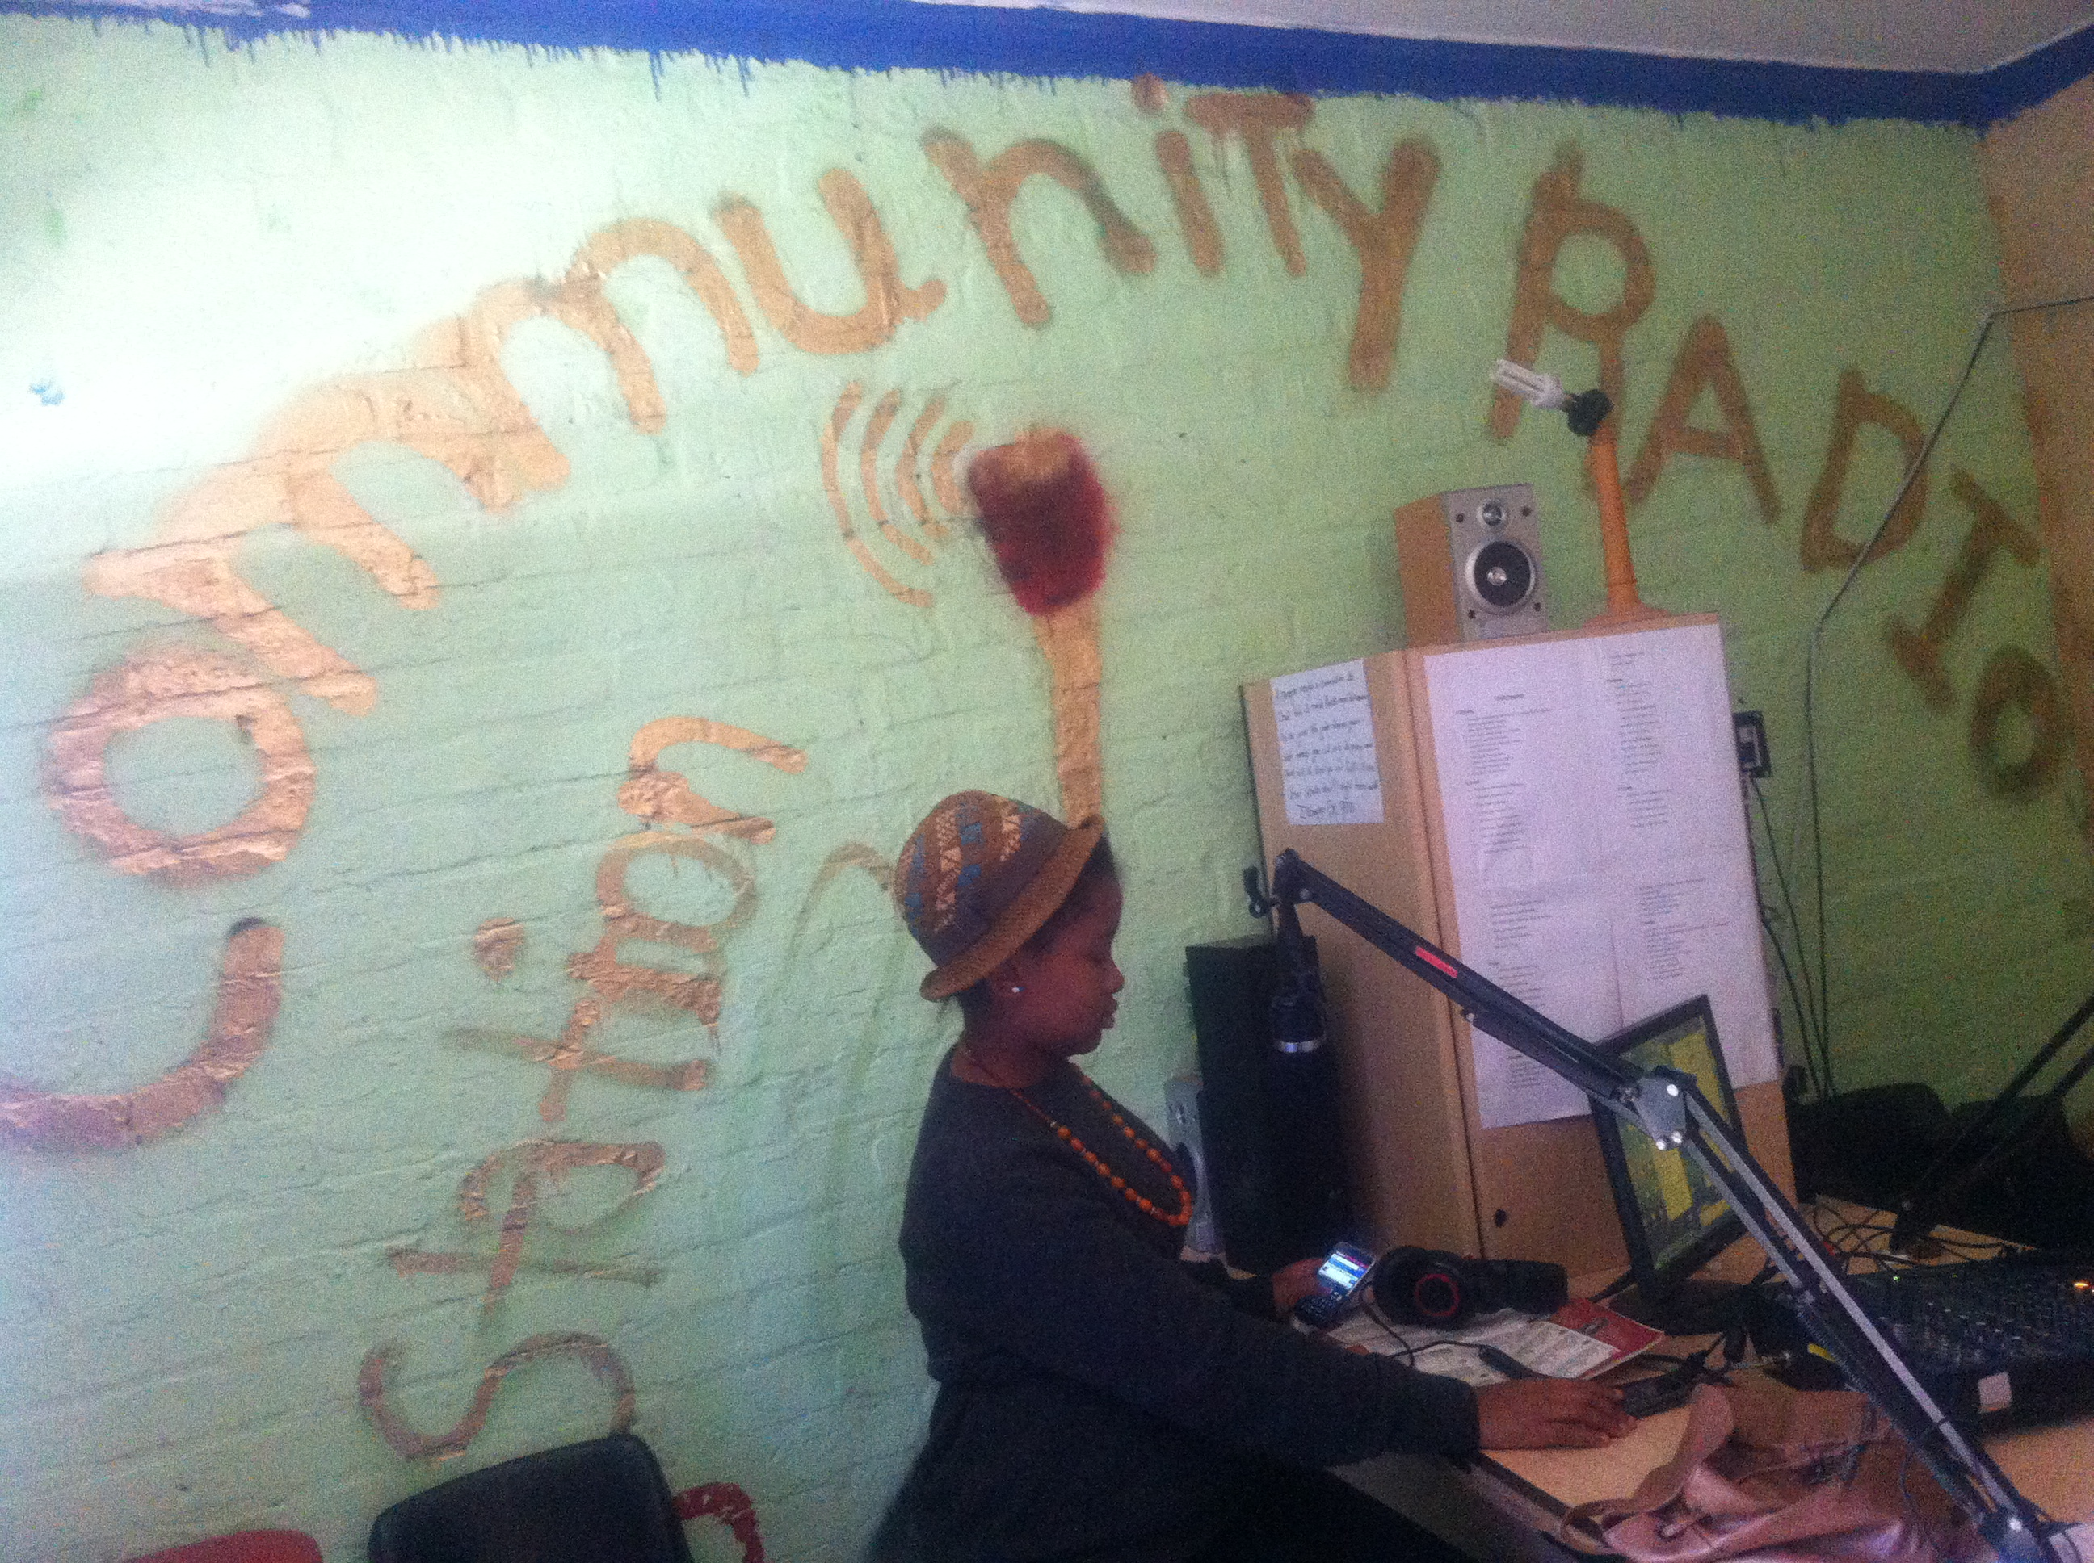
Figure 2 - Community radio station setting.

