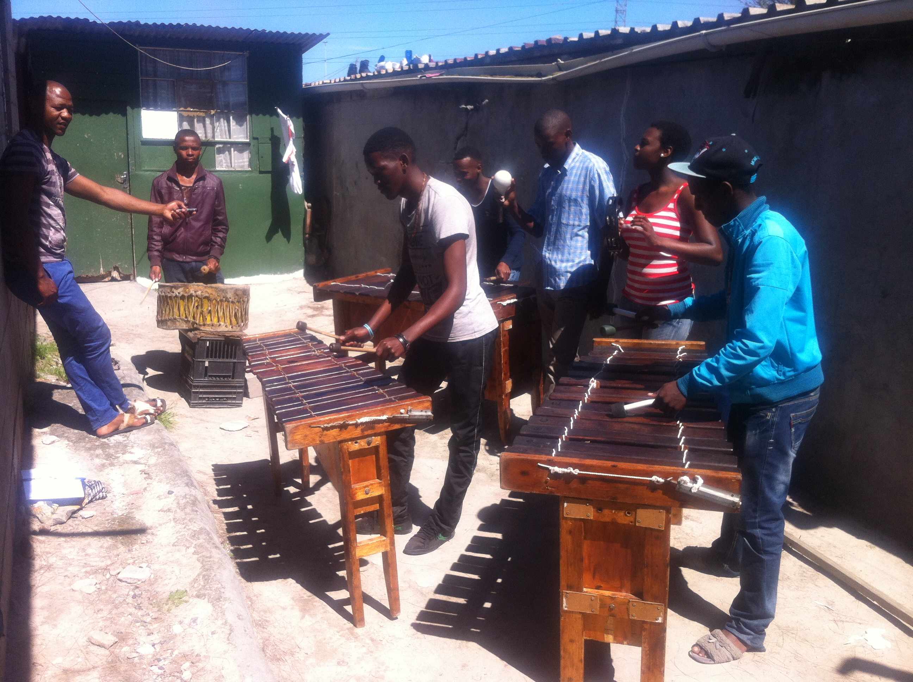
Figure 3 - The Hip-hop and marimbas jam session.

