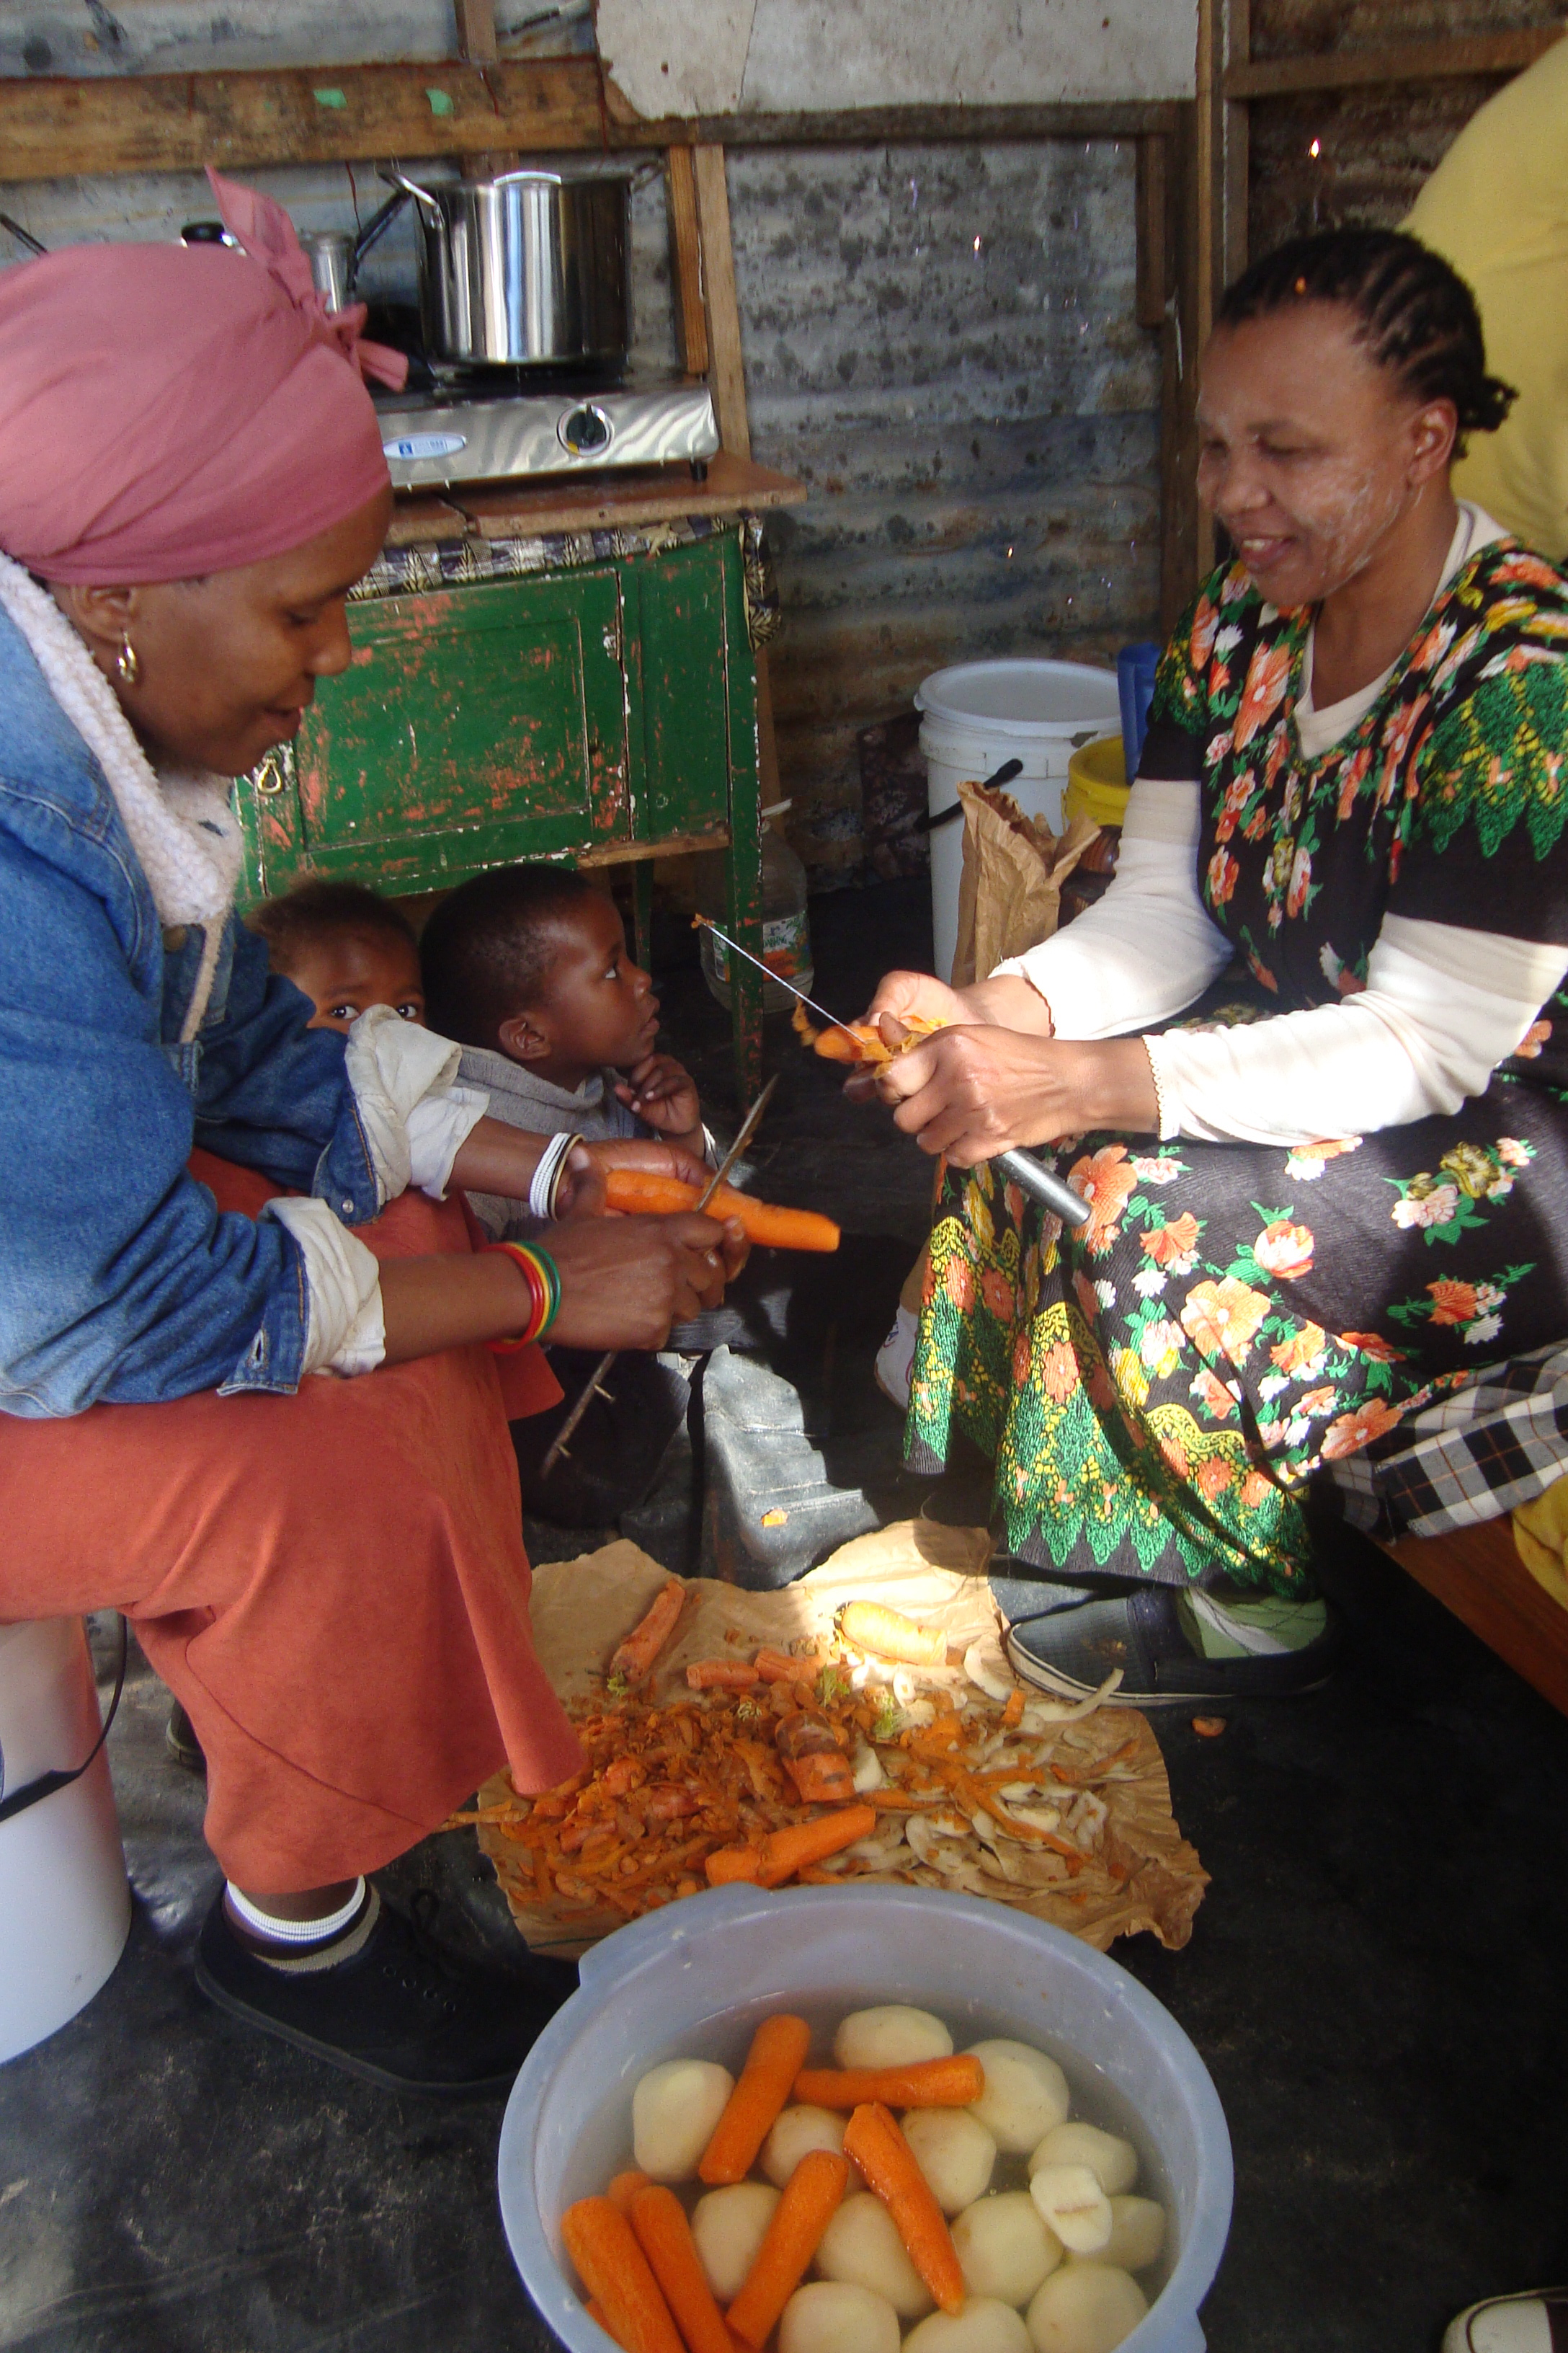
Figure 4 - The Mamas research setting.

