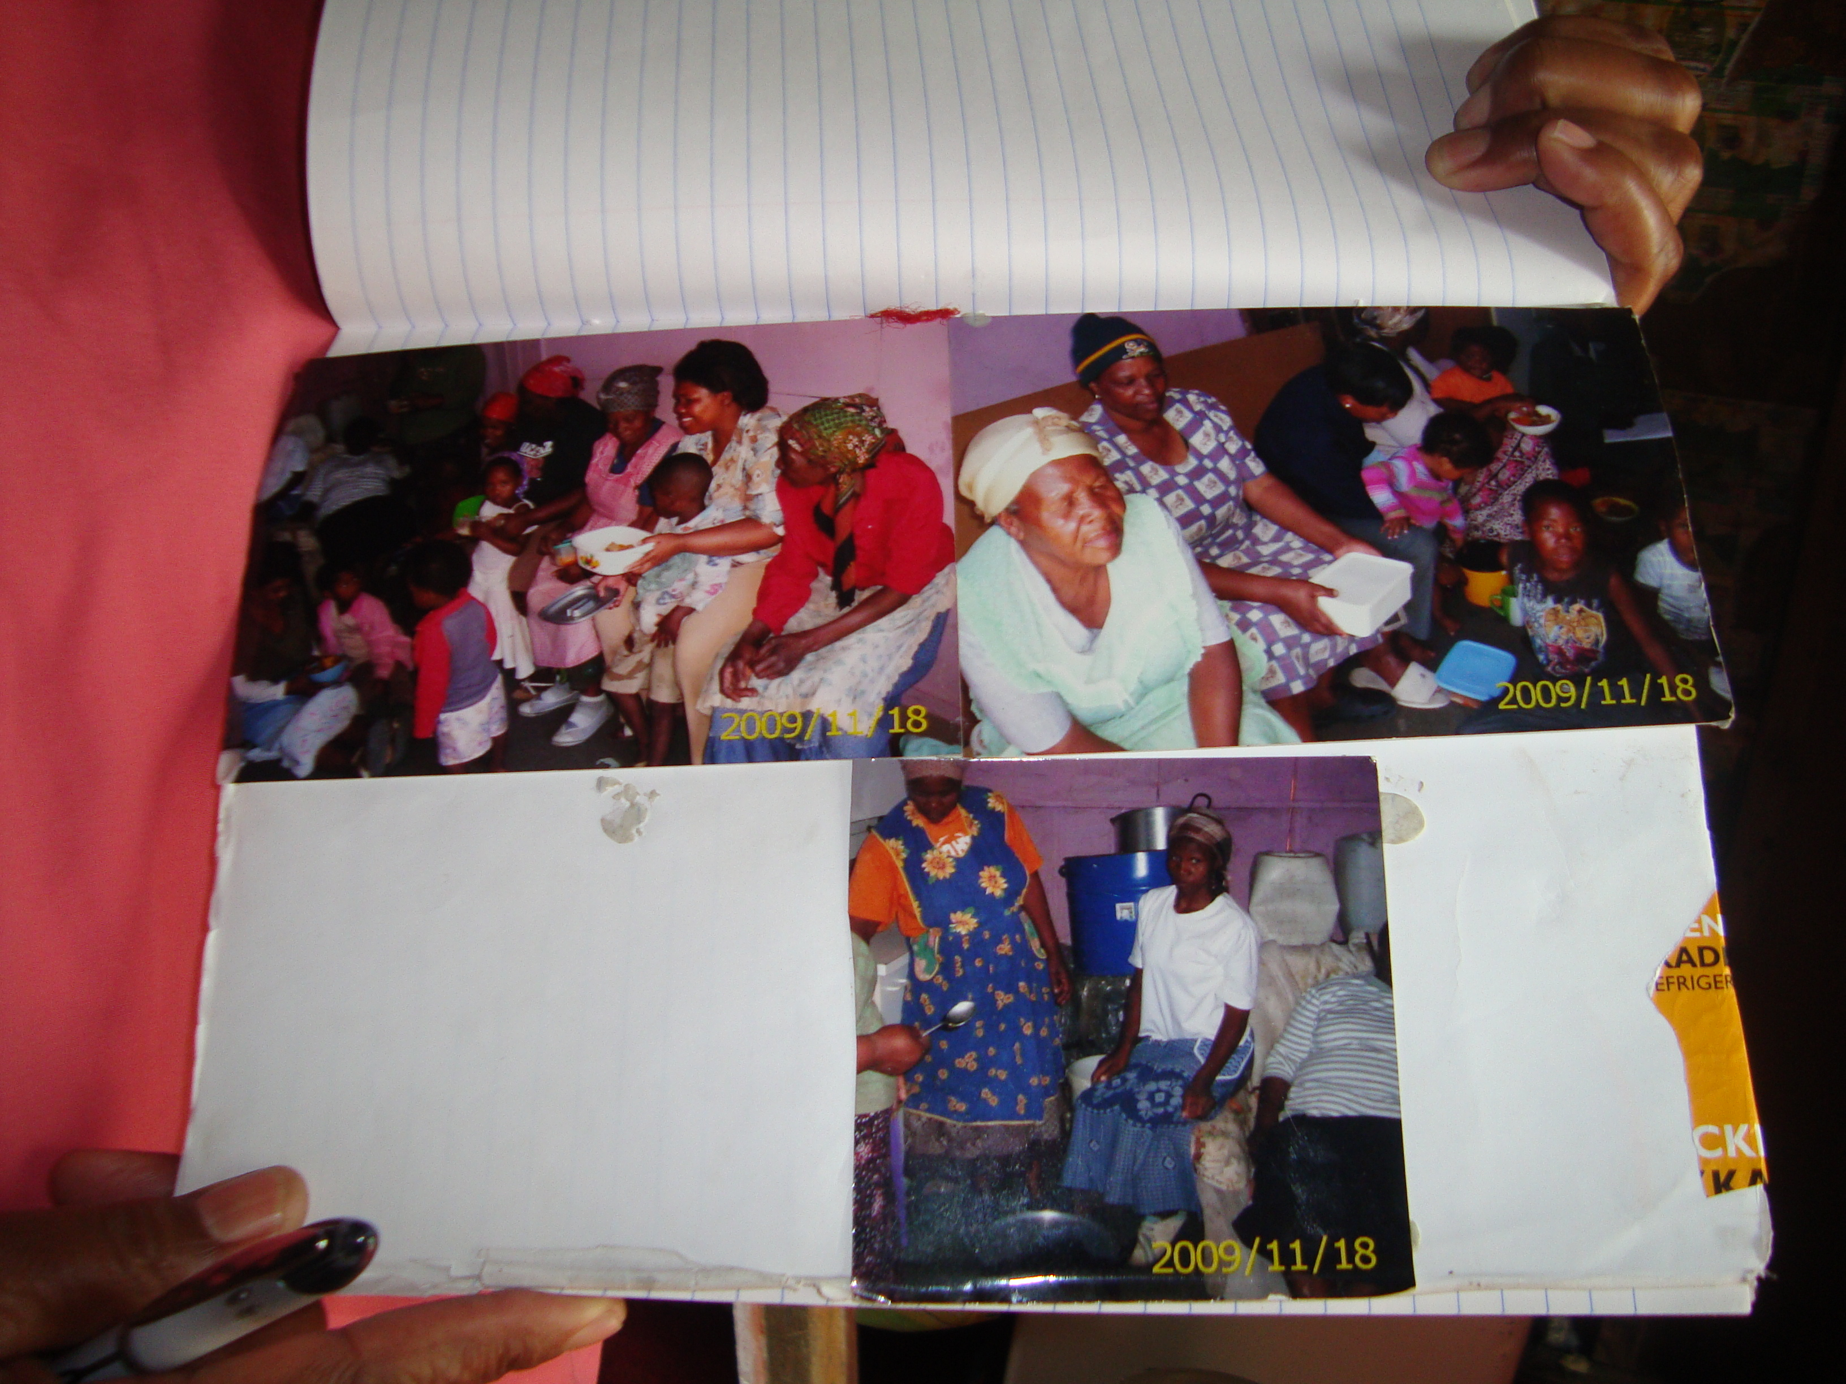

Figure 5 - During the video making process the Mamas used their photo-books to showcase community members and their work.